Title is in english max 15 words left alignment bold arial 14 sentence case

First Author*¹, Second Author², Third Author³
1, First Afiliation, Country
2, Second Afiliation, Country
3, Third Afiliation, Country

Article Info | Abstract
Keywords:  Internet of Things Platform, Internet of Things, Message Queuing Telemetry Transport, MQTT Broker Server  Article history:  Received 17 August 2018  Revised 15 February 2019  Accepted 4 April 2019  Available online 4 April 2019  Cite:  Wardana, A., Rakhmatsyah, A., Minarno, A., & Anbiya, D. (2019). Internet of Things Platform for Manage Multiple Message Queuing Telemetry Transport Broker Server. Kinetik: Game Technology, Information System, Computer Network, Computing, Electronics, and Control, 4(3). doi:http://dx.doi.org/10.22219/kinetik.v4i3.841  * Corresponding author.  Corresponding Author  E-mail address:  author@email.ac.id | A well-prepared abstract enables the reader to identify the basic content of a document quickly and accurately, to determine its relevance to their interests, and thus to decide whether to read the document in its entirety. The Abstract should be informative and completely self-explanatory, provide a clear statement of the problem, the proposed approach or solution, and point out major findings and conclusions. The Abstract should be 200 to 250 words in length. The abstract should be written in the past tense. Standard nomenclature should be used and abbreviations should be avoided. No literature should be cited. The keyword list provides the opportunity to add keywords, used by the indexing and abstracting services, in addition to those already present in the title. Judicious use of keywords may increase the ease with which interested parties can locate our article.
1. Introduction
The Introduction should provide a clear background, a clear statement of the problem, the relevant literature on the research subject, the proposed approach or solution or method, and the new value or novelty of research [1]. Organization and citation of the bibliography are made in Vancouver style [2]. The terms in foreign languages are written italic. Authors are suggested to present their articles in the section structure: Introduction, Research Method, Results and Discussion, Conclusion, References. Acknowledgement and Notation can be written before References section if needed.
The manuscripts must be submitted through the website http://kinetik.umm.ac.id by following the specified registration flow. The entire registration and submission process of manuscript are free of charge. The length of manuscript is minimum 6 pages and maximum 8 pages based on article format according to the provided template.

2. Research Method
Research method explains research chronological, including research design, research procedure (in the form of algorithms, pseudocode or other related things), how to test, and data acquisition process [3], [4]. Any description related to research method should be supported by reference.
Illustration on article can be figures and (or) tables. Figure and table are presented in center (center alignment) and placed immediately after paragraph in which figure and table are cited in the main text. All illustration should be cited in the text. Before and after figure/table should be given an empty line with single space (10 pt) as a space to text paragraph and two space (10 pt) as a space to another section.
Both, figure and table, should be named and captioned. The name and caption are italic style, center alignment, 10 pt font size, and single spacing. Ensure that both, name and caption, do not run across columns/pages. Table name and caption could be placed above the table, meanwhile figure name and caption could be placed below the figure. Dot should be written between the figure/table name and figure/table caption.
The name of figure/table uses Arabic number and then will be numbered according to their order of appearance in the main text. Tables are to be referred as Table 1, Tables 1, 3, and 4, Tables 3 to 5, and so on. Similarly, figures are to be referred as Figure 1, Figures 8 and 9, and so on. When sentence begins with a figure reference, abbreviation must be avoided.
Text in figure and table should be clearly readable. Figure and graph must be in good quality. Moreover, the style of lines in graph must be clearly distinguished. In print journal, all colored illustrations will be displayed in black-and-white color. Table is not in image form. Spacing between columns or between lines must be considered in order to avoid errors during the display arrangement. Figure 1 is an example of figures that can be seen clearly. To simplify the arrangement of figure that contains some images you should use a table using no border. Table 1 shows the example of table. The mathematical equation should be written using equation tools, not in image form. The mathematical equation is presented in center (center alignment), placed immediately after it is cited in text, and numbered according to their order of appearance in the main text.

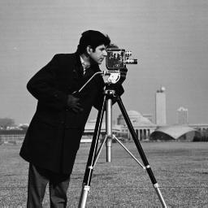  (a) | (b) | (c) | (d)
Figure 1. The example of figures that can be seen clearly

Table 1. An example of table caption
Variable | Speed (rpm) | Power (kW)
x | 10 | 8.6
y | 15 | 12.4
z | 20 | 15.3

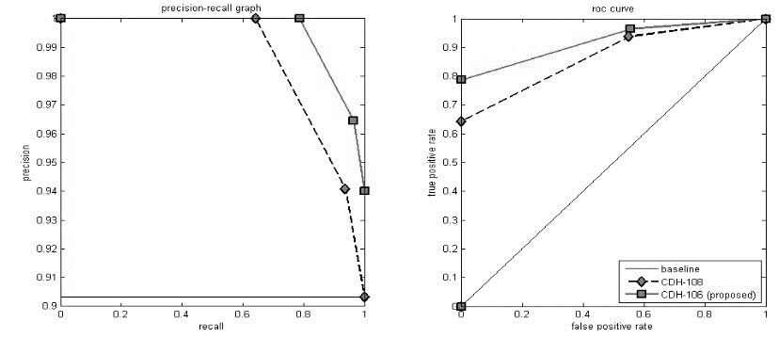
Figure 3. The example of figures that can be seen clearly

Numbering written using Arabic number, inside bracket, and right alignment. All mathematical equation should be cited in the text. Before and after mathematical equation should be given an empty line with single space 10 pt as a space to text paragraph and two space 10 pt as a space to another section. Equation(s) are to be referred in text as Equation 1, Equations 1 and 3, Equations 1 to 5 and so on. Avoid abbreviations if a sentence starts with any of these. The example of mathematical equation as defined in Equation 1.

$Corr=\sum_{i,j=0}^{L-1}{\frac{\left({i-μ}_{x}\right)\left({j-μ}_{y}\right)P\left(i,j,d,θ\right)}{σ_{x}σ_{y}}}$ (1)

Where $μ_{x}=\sum_{i,j=0}^{L-1}{i.P(i,j,d,θ)}$, $μ_{y}=\sum_{i,j=0}^{L-1}{j.P(i,j,d,θ)}$, $σ_{x}=\sum_{i,j=0}^{L-1}{{(i-μ_{x})}^{2}.P(i,j,d,θ)}$, $σ_{y}=\sum_{i,j=0}^{L-1}{{(j-μ_{y})}^{2}.P(i,j,d,θ)}$. The notation explanation of mathematical equation should be written in Notation section before References section and given unit according to The International System of Units (SI).

3. Results and Discussion
This section explains the results of research and at the same time is given the comprehensive discussion. Results can be presented in figures, graphs, tables and others that make the reader understand easily [5]. The discussion can be made in several sub-sections.

3.1. Sub Section 1
The issues should be explained in general to specific that are written systematically. The relevant references should be used to describe each issue. Each reference used must be written in bibliography or References section and each reference written in References section must be cited in the main text.

3.2. Sub Section 2
Each paragraph consists of one main sentence and several explanatory sentences. The explanations should be delivered systematically and provide information about how the authors do, related to data, methods, or stages that conducted.

4. Conclusion
Provide a statement that what is expected as stated in the Introduction section, and obtained in Results and Discussion section. Moreover, it can also be added the prospect of the development of research results and application prospects of further studies into the next (based on result and discussion).

Notation
The example of notation can be described with the following description:
n : the number of data
Mi : the median value of i-th class.
$μ$ : the average value of data.
Fi : Frequency of i-th data.

Acknowledgement
Thank you to the Internet of Things Studio, Telkom University which has become a place for researchers to develop this journal research. Hopefully, this research can make a major contribution to the advancement of technology in Indonesia.

References
The minimal number of references used in manuscript must be 25 references using APA Style. The main references are reputed international journals or proceeding and doi hyperlink must be provided. All references should be to the most pertinent and up-to-date sources. In reference and citation are mandatory using reference apps such as Mendeley. Please use the reference writing procedure provided in this guide:

References
- M. Chernyshev, Z. Baig, O. Bello, and S. Zeadally, “Internet of Things (IoT): Research, Simulators, and Testbeds,” IEEE Internet of Things Journal., Vol. 5, No. 3, Pp. 1637–1647, 2018. https://doi.org/10.1109/JIOT.2017.2786639
- J. Rui and S. Danpeng, “Architecture Design of the Internet of Things based on Cloud Computing,” in Seventh International Conference on Measuring Technology and Mechatronics Automation, Pp. 206–209, 2015. https://doi.org/10.1109/ICMTMA.2015.57
- H. C. Hwang, J. Park, and J. G. Shon, “Design and Implementation of a Reliable Message Transmission System Based on MQTT Protocol in IoT,” Wireless Pers Commun., Springer, 2016. https://doi.org/10.1007/s11277-016-3398-2
- W. Pipatsakulroj, V. Visoottiviseth, and R. Takano, “muMQ: A Lightweight and Scalable MQTT Broker,” in IEEE International Symposium on Local and Metropolitan Area Networks (LANMAN), 2017. https://doi.org/10.1109/LANMAN.2017.7972165
- A.Zabasta, et. al, “MQTT Service Broker for Enabling the Interoperability of Smart City Systems,” in IEEE Energy and Sustainability for Small Developing Economies (ES2DE), 2018. https://doi.org/10.1109/ES2DE.2018.8494341

